Enabling Python on the Sentrius BT510 Sensor

The Canvas Firmware has been ported to the Sentrius BT510 Sensor. This guide describes the steps required to program a Sentrius BT510 sensor with the python-capable Canvas Firmware for rapid application development.

BT510 Canvas Firmware

Canvas Firmware is required to run the BT510 Tilt demo. Canvas firmware can be found at <https://github.com/Ezurio/canvas_python_firmware>.

**Programming the Canvas Firmware Image onto the BT510 Sensor**

The BT510 sensor can be programmed and interacted with via UART using the [Ezurio USB-SWD Programming Kit](https://www.ezurio.com/wireless-modules/programming-kits/usb-swd-programming-kit).

453-00062-K1 - USB-SWD Programming Kit

**Here are the general steps required to program a firmware image .hex file on the BT510:**

1. Install [Python 3.11.6](https://www.python.org/downloads/) (Newer versions of Python may not work with this demo)
2. [Install or update pip](https://pip.pypa.io/en/stable/installation/) if not installed (usually pip is automatically installed with Python)
3. Install **pyocd** ([using pip](https://pyocd.io/docs/installing))
4. Attach the Ezurio USB-SWD Kit to your workstation and attach the Tag-Connect cable to the back of the BT510 sensor.  
   A close-up of a circuit board

   Description automatically generated
5. **Make sure the SW5 switch is in the 3V3 position**
6. Ensure you are in the folder containing the firmware .hex file and open a command prompt in that folder. Use pyocd to program the .hex file of your choice onto the BT510. This example uses the version of firmware that keeps the UART enabled for development purposes.

pyocd flash -t nrf52840 -e chip build.bt510_2.0.0.1739402471_merged.hex

1. Identify the serial/COM/UART/TTY port associated with your USB-SWD kit and open it in a serial terminal using **115200 baud, 8N1** for serial port settings.
2. Reset the BT510 by issuing the following command with pyocd

pyocd reset -t nrf52840

1. If you see a prompt containing **>>>**, your BT510 sensor is now running python!
2. Follow the next sections to use the python REPL and/or install python scripts on to the BT510.

Using the Python REPL on the BT510 Sensor

Attaching the serial port of the BT510 to a serial terminal application on your workstation provides access to the python “Read-Eval-Print-Loop” or **REPL** interface console. This prompt is typically seen as three greater-than signs:

>>>

At this prompt, you can enter python code directly and it will be evaluated by the on-device python interpreter. For example, as a quick test, you can type the following to demonstrate printing to the console from within a python application:

>>> print('Hello, World!')

Hello, World!

>>>

From this interface, you can also perform filesystem operations and have access to many APIs for operating the underlying BT510 Sensor hardware.

Updating Python Scripts on the BT510 Sensor

**Using the Xbit VS Code Extension**

To program a python script (such as the **tiltad script** below) onto the attached BT510, drag and drop the python source code file onto the device in the **USB DEVICES** panel of the Xbit VS Code extension. After the file is transferred and shows up in the tree view, right click and select **Rename File** and name the file main.py.

At this point, the drag-and-dropped python script has been written to the attached BT510 Sensor device as a file in its filesystem named main.py. This is a special filename that the python engine is configured to automatically run after reset if it exists in the filesystem.

To start the BT510 Sensor running the newly downloaded python script, **reset** the device by its power supply or type **Ctrl+D** into the REPL console.

BT510 tilt sensor script 1.5.0

------------------------------

BLE Name: BT510-99

Reporting Interval: 100ms

Press ctrl-c within 15 seconds to access the REPL and cancel low power mode

Entering low power mode, UART REPL will turn off in 20 seconds...

**NOTE:** You have 15 seconds to press CTRL+C on the REPL console to keep the UART awake for development or interacting with the BT510, otherwise the script will put the UART peripheral in sleep mode to reduce power consumption (better low power mode for use when powered by the coin cell battery) making the REPL unavailable.

BT510 Sensor Python Scripts

**The “tiltad” Application Script**

The tiltad python script can be found in the Canvas Python Samples repository:

<https://github.com/Ezurio/canvas_python_samples>

The tiltad.py script provides a simple periodic read of accelerometer axis data and reporting in standard Bluetooth Low Energy advertisement packets. When programmed as the main.py on a BT510 sensor, this script loops infinitely, waking up every 100ms to read accelerometer axis data and update the data in the BLE advertisement.

Viewing the BT510 Tilt Sensor Data

The [Canvas Xbit Desktop](https://github.com/Ezurio/Canvas_Xbit_Desktop) tool includes a BT510 Tilt SensorApplet designed to display the tilt of a BT510 provided by the BLE advertisements from the **tiltad** python script running on a BT510.   
  
**NOTE**: These instructions assume you have already programmed a [BL654 USB adapter (**Part #: 451-00004)](https://www.ezurio.com/wireless-modules/bluetooth-modules/bluetooth-5-modules/bl654-series-bluetooth-module-nfc) with the [Canvas Firmware image](https://github.com/Ezurio/canvas_python_firmware) running the [xbit_usb python script](https://github.com/Ezurio/canvas_python_samples).

Open the serial port associated with your BL654 USB Adapter from within the Xbit Desktop tool. If the FW and xbit_usb script were properly loaded it will appear as shown below in the Xbit for Desktop app. Be sure to **click** “**Connect**” to select the device before moving to Applets screen.  
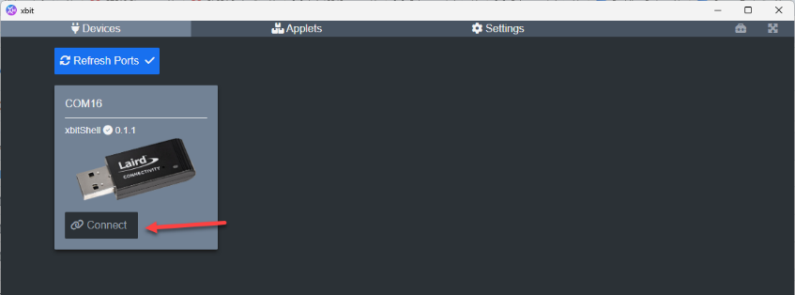

Next, start the BT510 Tilt Sensor Applet. Navigate to the **Applets** tab. Click the **Install** button on the Applet named **BT510 Tilt Sensor**, then **Launch** to launch it.  
  
In the Applet, click the **Start Scan** button to begin updating the 3D model of the BT510 based on received BLE advertisement data. As the BT510 sensor orientation changes, the 3D model in the Applet will update to match based on the data from its internal accelerometer.

